81. Component Event - 02 August 2022

**Event**

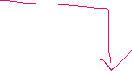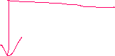

System Event

Component Event

Application Event

**2] Component Event**



Component event is used to transfer the data from Child Component to Parent Component.

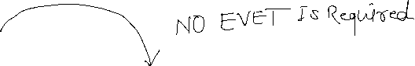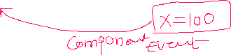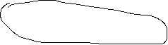

1] Parent 🡺 Child

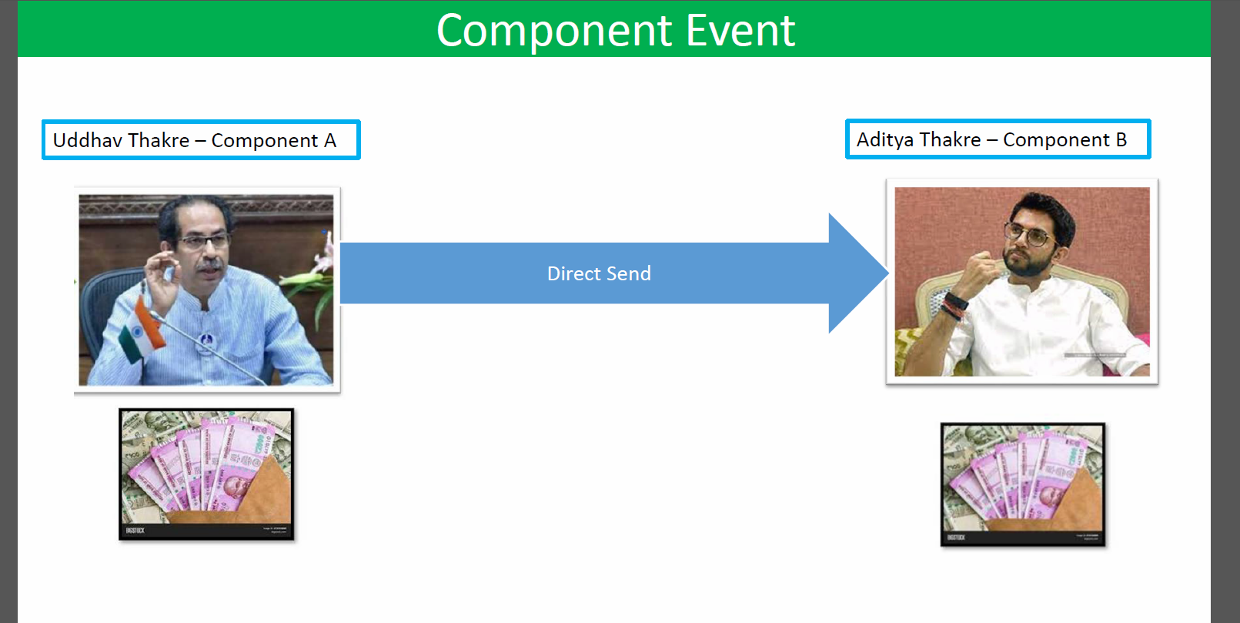

**User Story 1]**

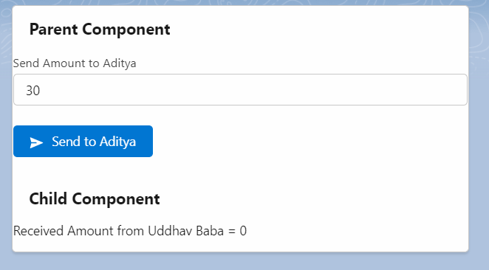

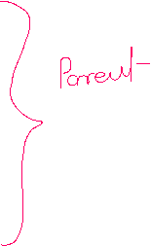

Parent Component:

<aura:component implements="force:appHostable,flexipage:availableForAllPageTypes,flexipage:availableForRecordHome,force:hasRecordId,forceCommunity:availableForAllPageTypes,force:lightningQuickAction" access="global" >

<aura:attribute name="parentAmount" type="Decimal" default="0" />

<aura:attribute name="sendParentAmount" type="Decimal" default="0" />

<lightning:card title="Parent Component">

<lightning:input type="text" label="Send Amount to Aditya" value="{!v.parentAmount}" /><br/>

<lightning:button variant="brand" label="Send to Aditya" iconName="utility:send" onclick="{!c.sendToAdityaController}"/>

<!--Calling Child Compo-->

<c:AdityaCompo receivedAmountFromParent="{!v.sendParentAmount}" />

</lightning:card>

</aura:component>

({

sendToAdityaController : function(component, event, helper) {

component.set('v.sendParentAmount', component.get('v.parentAmount'));

}

})

Child Component:

<aura:component implements="force:appHostable,flexipage:availableForAllPageTypes,flexipage:availableForRecordHome,force:hasRecordId,forceCommunity:availableForAllPageTypes,force:lightningQuickAction" access="global" >

<aura:attribute name="receivedAmountFromParent" type="Decimal" default="0" />

<lightning:card title="Child Component">

Received Amount from Uddhav Baba = <ui:outputText value="{!v.receivedAmountFromParent}" />

</lightning:card>

</aura:component>

2] Child 🡺 Parent

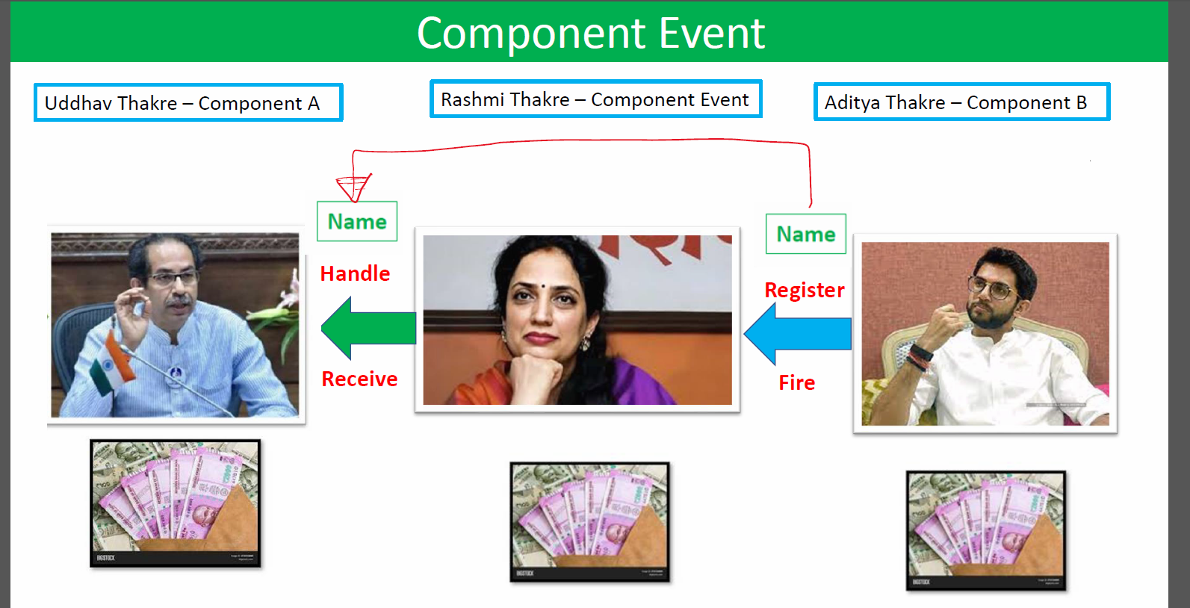

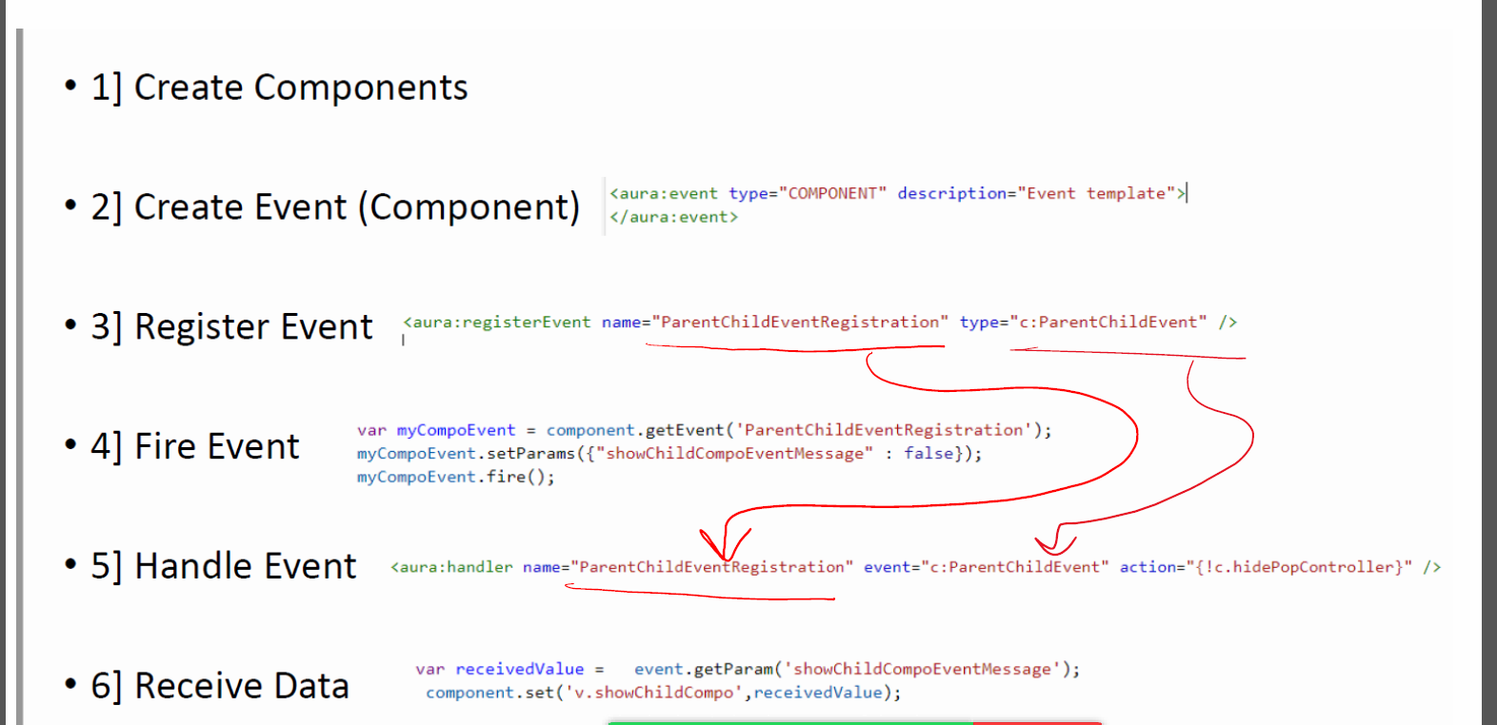



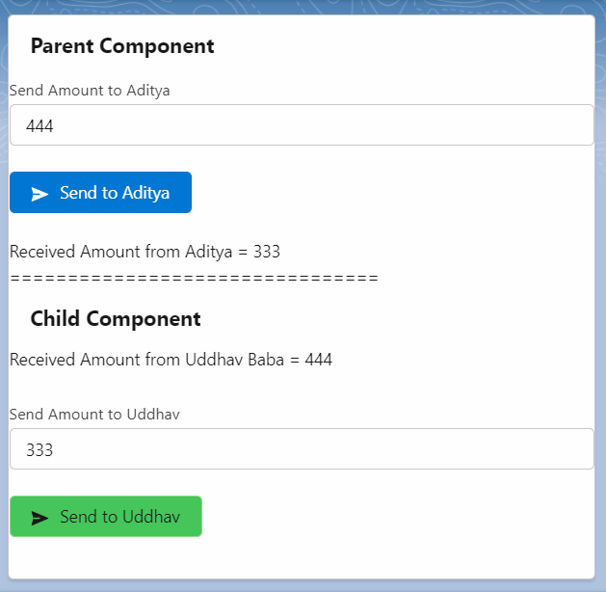

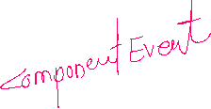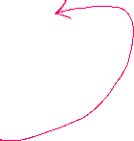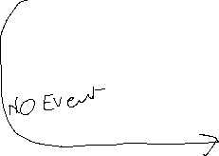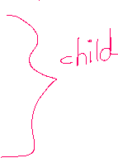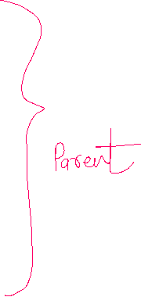

Event : Component Event

<aura:event type="COMPONENT" description="Event template">

<aura:attribute name="rashmiEventAmount" type="Decimal" />

</aura:event>

Parent Compo:

<aura:component implements="force:appHostable,flexipage:availableForAllPageTypes,flexipage:availableForRecordHome,force:hasRecordId,forceCommunity:availableForAllPageTypes,force:lightningQuickAction" access="global" >

<aura:attribute name="parentAmount" type="Decimal" default="0" />

<aura:attribute name="sendParentAmount" type="Decimal" default="0" />

<aura:attribute name="receivedAmountFromAditya" type="Decimal" default="0" />

<!--Event Handle-->

<aura:handler name="RashmiEventRegistration" event="c:RashmiEvent" action="{!c.receiveDataController}" />

<lightning:card title="Parent Component">

<lightning:input type="text" label="Send Amount to Aditya" value="{!v.parentAmount}" /><br/>

<lightning:button variant="brand" label="Send to Aditya" iconName="utility:send" onclick="{!c.sendToAdityaController}"/> <br/>

Received Amount From Aditya = {!v.receivedAmountFromAditya}

<!--Calling Child Compo-->

<c:AdityaCompo receivedAmountFromParent="{!v.sendParentAmount}" />

</lightning:card>

</aura:component>

JS Controller:

({

sendToAdityaController : function(component, event, helper) {

component.set('v.sendParentAmount', component.get('v.parentAmount'));

},

receiveDataController : function(component, event, helper) {

console.log("Zatka Laga...!!!");

var receivedData = event.getParam("rashmiEventAmount");

component.set('v.receivedAmountFromAditya' , receivedData);

}

})

Child Component:

<aura:component implements="force:appHostable,flexipage:availableForAllPageTypes,flexipage:availableForRecordHome,force:hasRecordId,forceCommunity:availableForAllPageTypes,force:lightningQuickAction" access="global" >

<aura:attribute name="receivedAmountFromParent" type="Decimal" default="0" />

<aura:attribute name="sendToUddhavBaba" type="Decimal" default="0" />

<!--Register Event-->

<aura:registerEvent name="RashmiEventRegistration" type="c:RashmiEvent" />

<lightning:card title="Child Component">

Received Amount from Uddhav Baba = <ui:outputText value="{!v.receivedAmountFromParent}" /> <br/>

<lightning:input type="text" label="Send Amount to Uddhav Baba" value="{!v.sendToUddhavBaba}" /> <br/>

<lightning:button variant="success" iconName="utility:send" label="Send to Uddhav Baba" onclick="{!c.sendToUddhavController}" />

</lightning:card>

</aura:component>

JS CONTROLLER:

({

sendToUddhavController : function(component, event, helper) {

var myCompnentEvent = component.getEvent("RashmiEventRegistration");

myCompnentEvent.setParams({"rashmiEventAmount" : component.get('v.sendToUddhavBaba')});

myCompnentEvent.fire();

}

})

LWC

[**async/await and promise functions in LWC**](https://salesforce.stackexchange.com/questions/278655/async-await-functions-in-lwc)